**AMENDMENT** to MATERIAL MANAGEMENT FORM

***DATA STRUCTURE :*** Alter Materials table to include ***Presentation***

|  |  |  |  |
| --- | --- | --- | --- |
| Materials | |  |  |
| PK | IDmaterial |  |  |
|  | name |  | text |
|  | IDmaterialType | FK |  |
|  | IDmeasurementUnits | FK |  |
|  | IDtypeOfManagement | FK |  |
|  | dangerous |  | boolean |
|  | product trade or brand name |  | text |
|  | active ingredients |  | text |
|  | ***….*** |  |  |
|  | ***Presentation ( new)*** |  | Small.int |
|  | ……. |  |  |

|  |  |  |  |  |  |  |  |
| --- | --- | --- | --- | --- | --- | --- | --- |
| ***Material Id*** | ***Material Name*** | ***Material Type Id*** | ***Measurment Units Id*** | ***Dangerous*** | .. | ***Presentation*** | ***..*** |
| *001* | *MaxiGrow* | *101* | *004* | *1 ( yes)* |  | *50* |  |
| *002* | *MaxiGrow* | *101* | *004* | *1 ( yes)* |  | *100* |  |

When user registers New Material under Warehouse 🡪 Materials

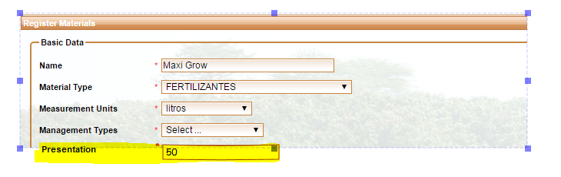

Material Management List:

1. Add ***Presentation*** as column on UI
2. List columns in following order : Material Type, Material, Product Trade /Brand Name, Presentation, Units, Dangerous, Responsible ,…( leave the rest as is)

|  |  |  |  |  |  |  |  |
| --- | --- | --- | --- | --- | --- | --- | --- |
|  | Material Type | Material | Trade Name/ Brand | Presentation | Units | Dangerous | Responsible |
|  | FERTILIZANTES | [MaxiGrow](http://52.24.109.156:8080/PrototipoCostos/warehouse/materials/registerMaterials.jsf) | General Hydroponics | 50 | Liter | **✓** | Juan Manuel |
|  | FERTILIZANTES | [MaxiGrow](http://52.24.109.156:8080/PrototipoCostos/warehouse/materials/registerMaterials.jsf) | General Hydroponics | 100 | Liter | **✓** | … |
|  | FERTILIZER | ZINC | Matalosato | … | Liter |  |  |
|  | FERTILIZER | ZINC | Hunitec |  | Liter |  |  |